TASK ON VPC
1)Create VPC with 2 private and 2 public subnets.
Go to AWS Management Console
Navigate to VPC Dashboard
Click Create VPC
Select:
Name: My-VPC
IPv4 CIDR: 10.0.0.0/16
Click Create
Create Subnets:
Go to Subnets → Create Subnet
Create 4 subnets:

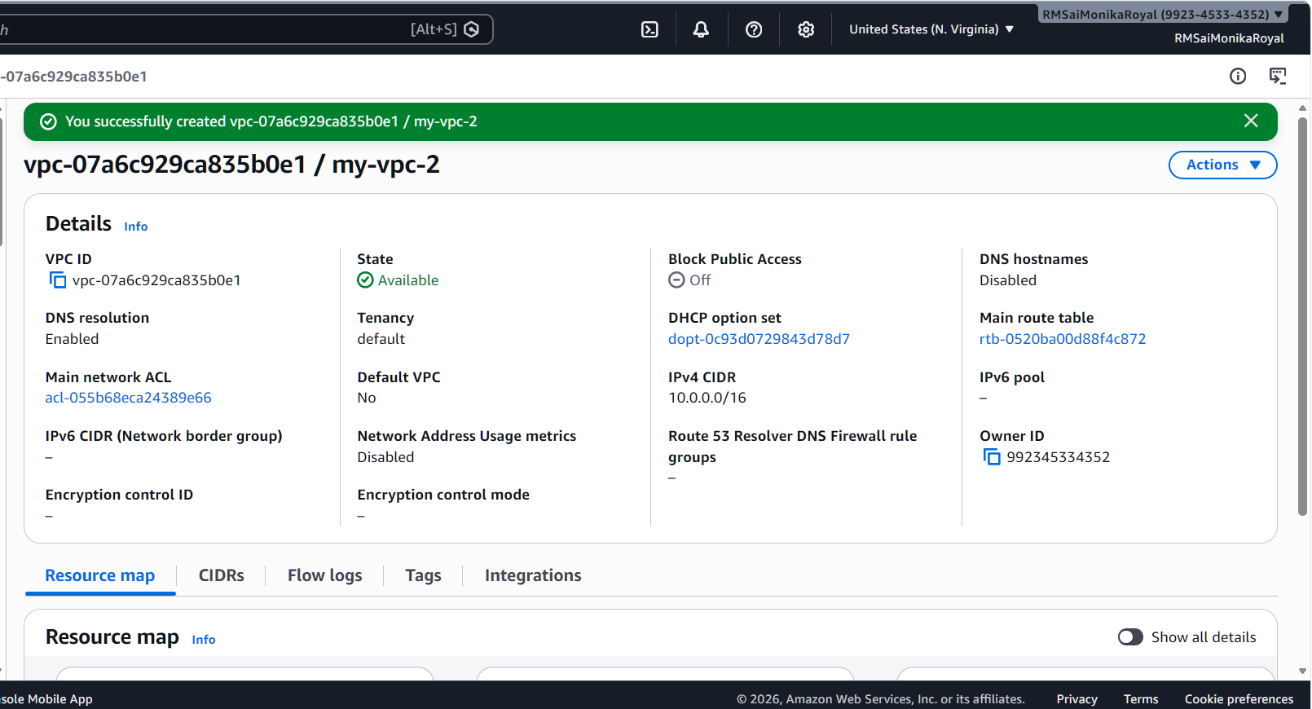
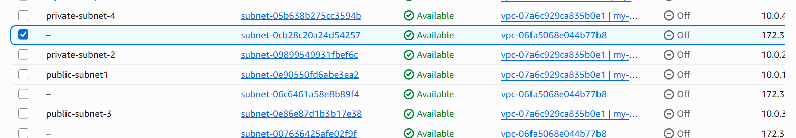
2)Enable DNS Hostname in VPC.
Go to VPC → Your VPCs
Select your VPC
Click Actions → Edit VPC Settings
Enable:
DNS Resolution
DNS Hostnames

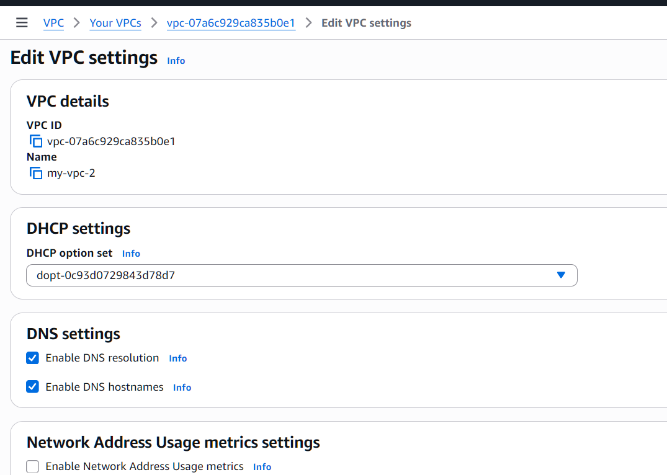
3) Enable Auto Assign Public IP in 2 public subnets.
Go to Subnets
Select Public-1 & Public-2
Click Actions → Modify Auto Assign IP
Enable Auto-assign Public IPv4
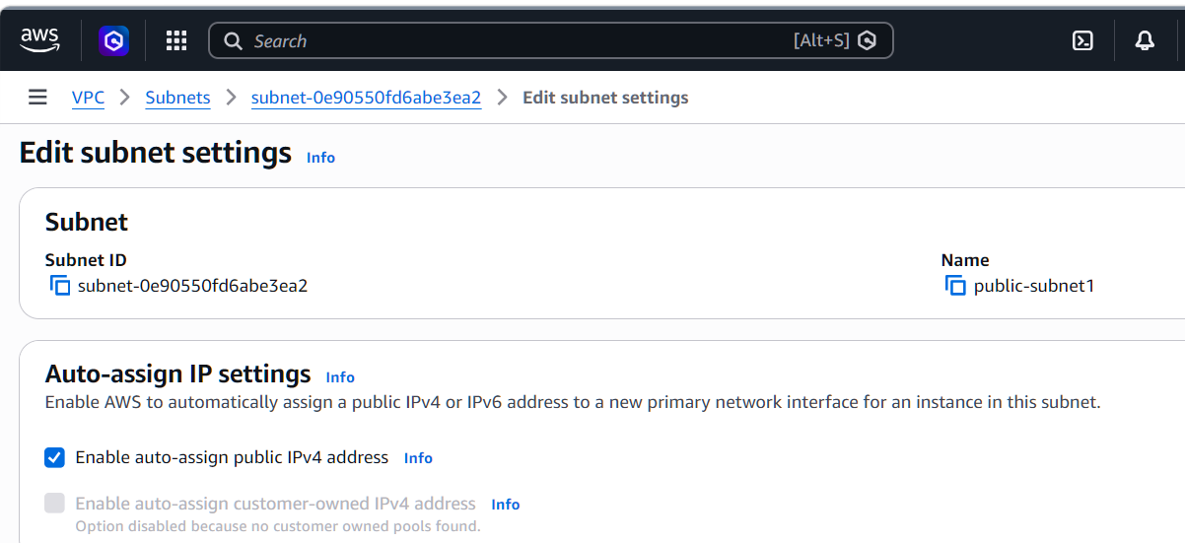
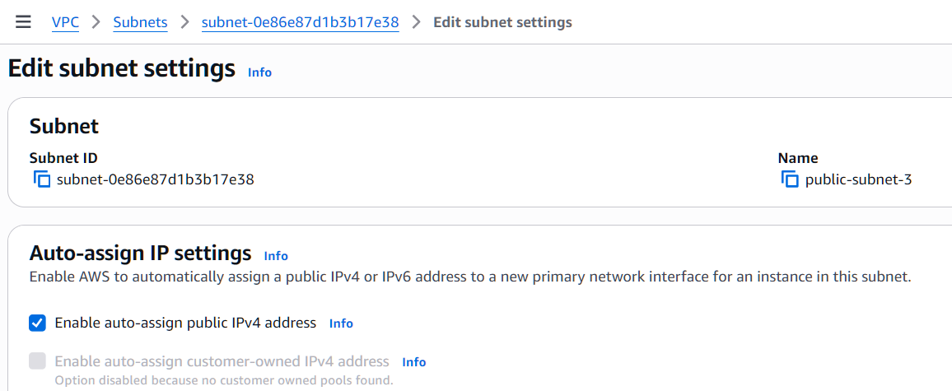
4) Add 2 private subnets in private route table.
First created a private route table
Edited subnet assosiations by adding two private subnets
Saved the associations
Checked whether they are added
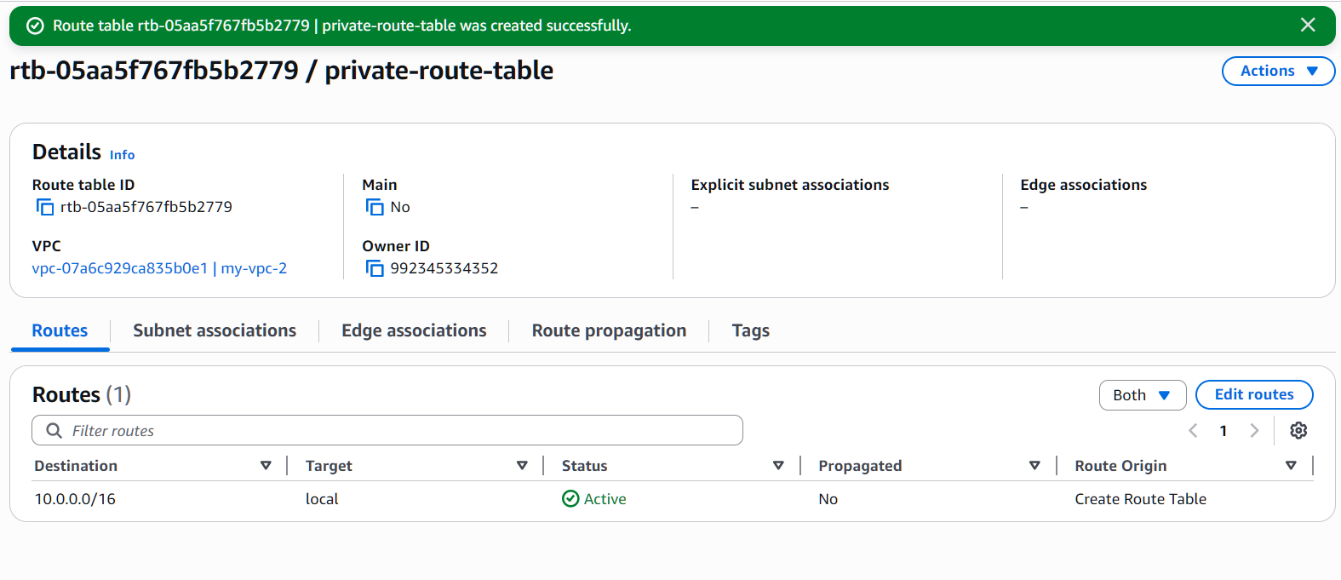
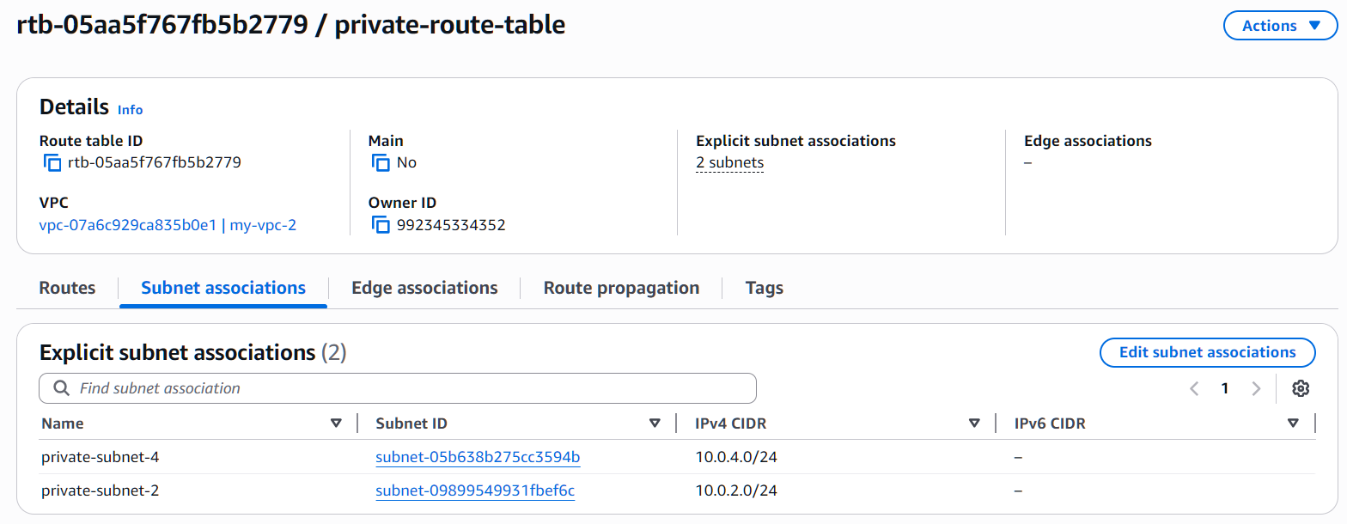
5) Add 2 public subnets in public route table.
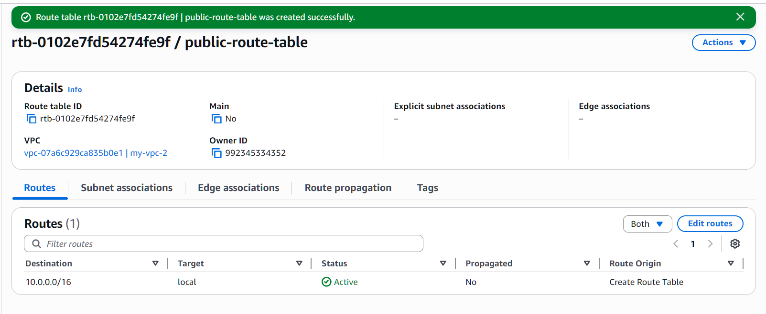
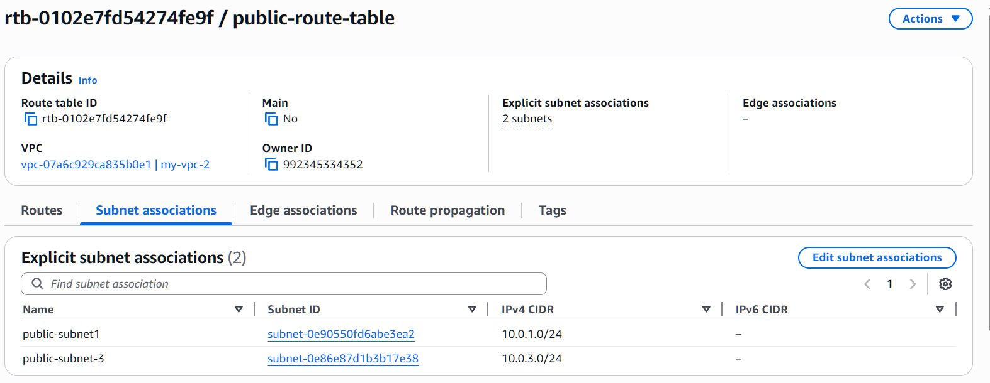
6) Public route table will have the routes to internet and local.
I have created a internet gateway
Attached internet gateway to VPC
I have added routes by selecting edit route and saved changes
Viewed the route table

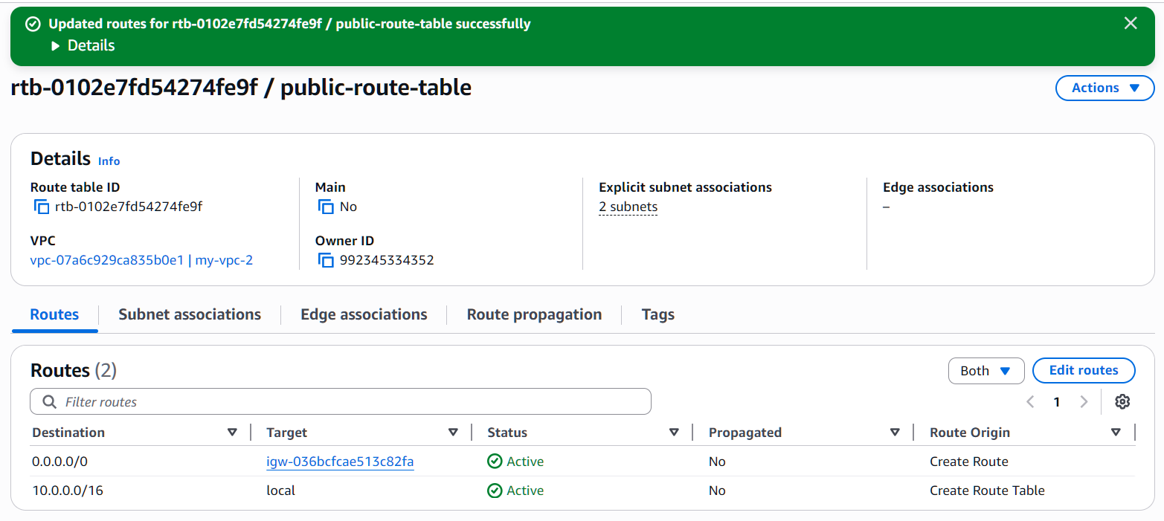
7) Create EC2 in public subnet with t2.micro and install PHP.
-Launched a new instance
Under Network Settings:
VPC: Select your VPC (MyVPC)
Subnet: Select public-subnet-02
Enable Auto-assign Public IP
I have connected EC2
Installed PHP with the below commands
- sudo yum update -y
- sudo yum install php
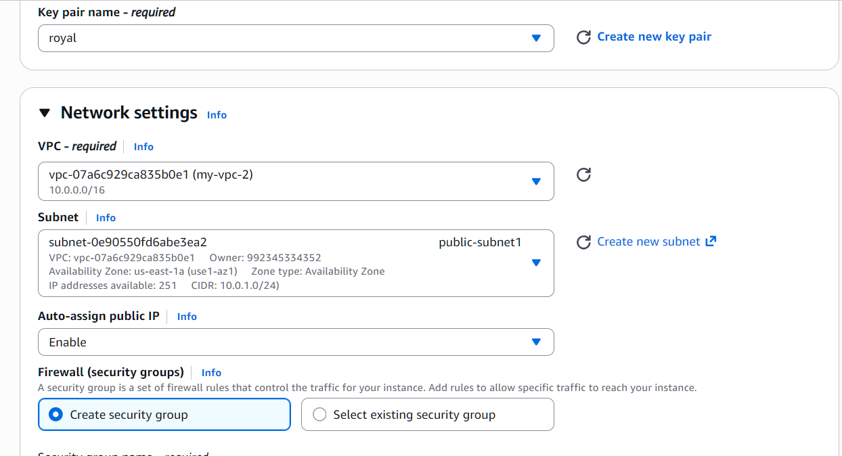
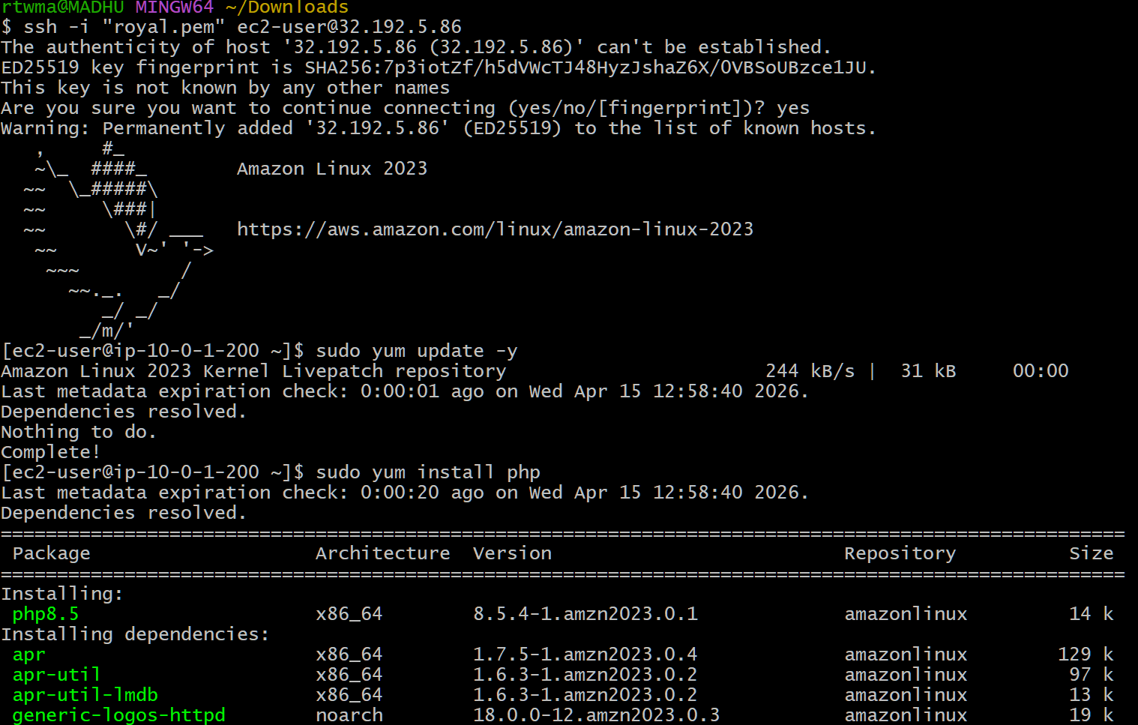
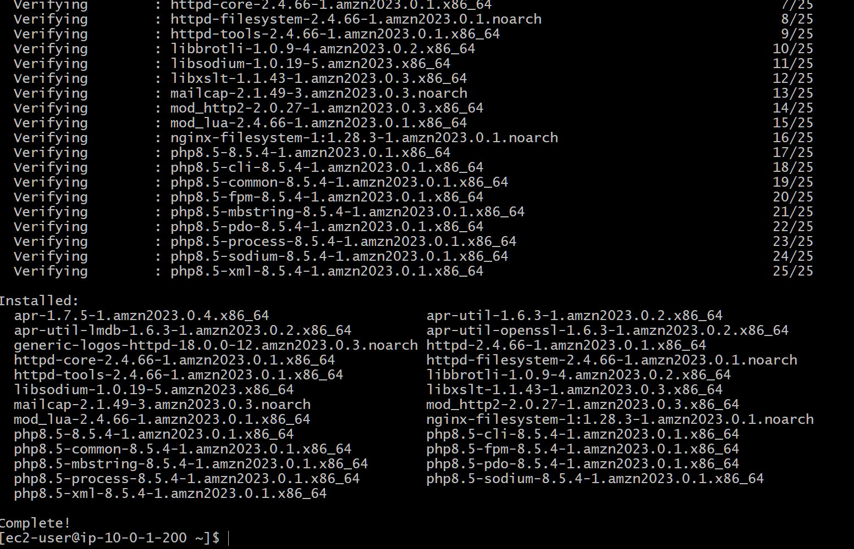
8) Configure NAT gateway in public subnet and connect to private instance.
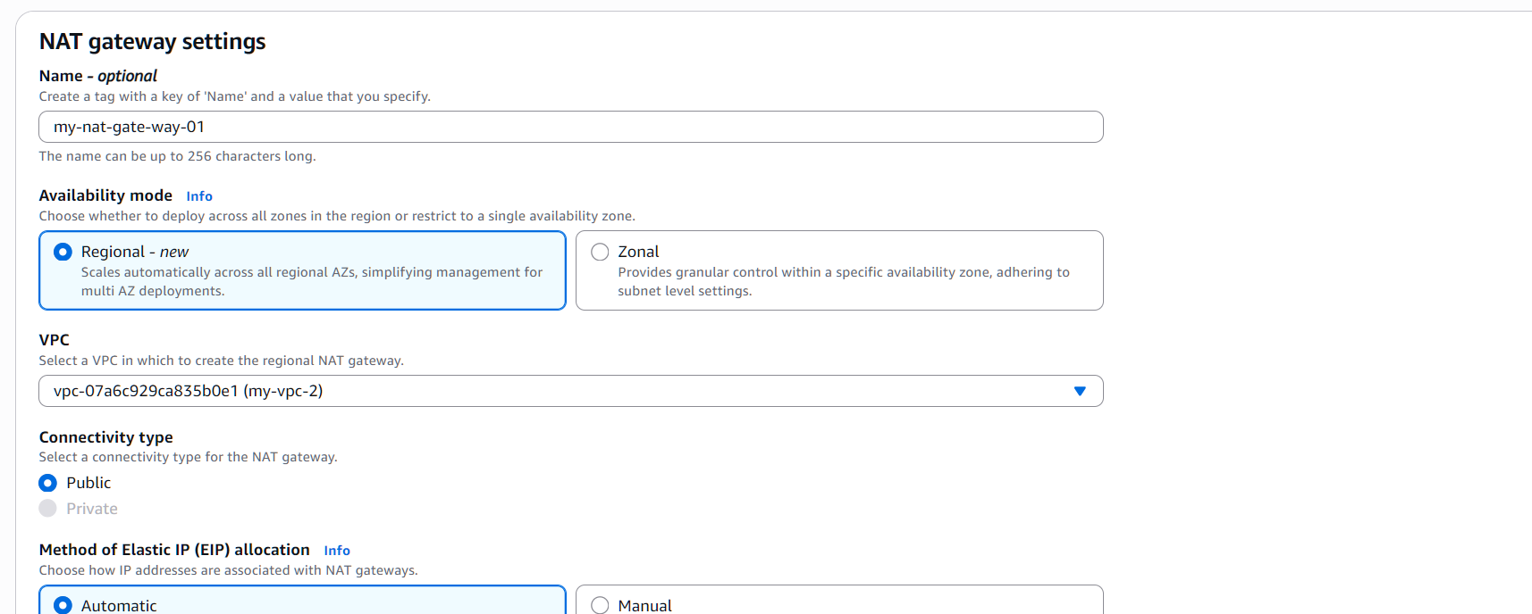
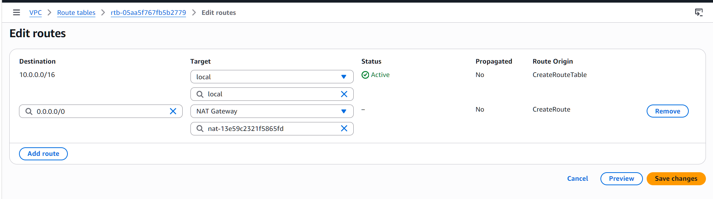
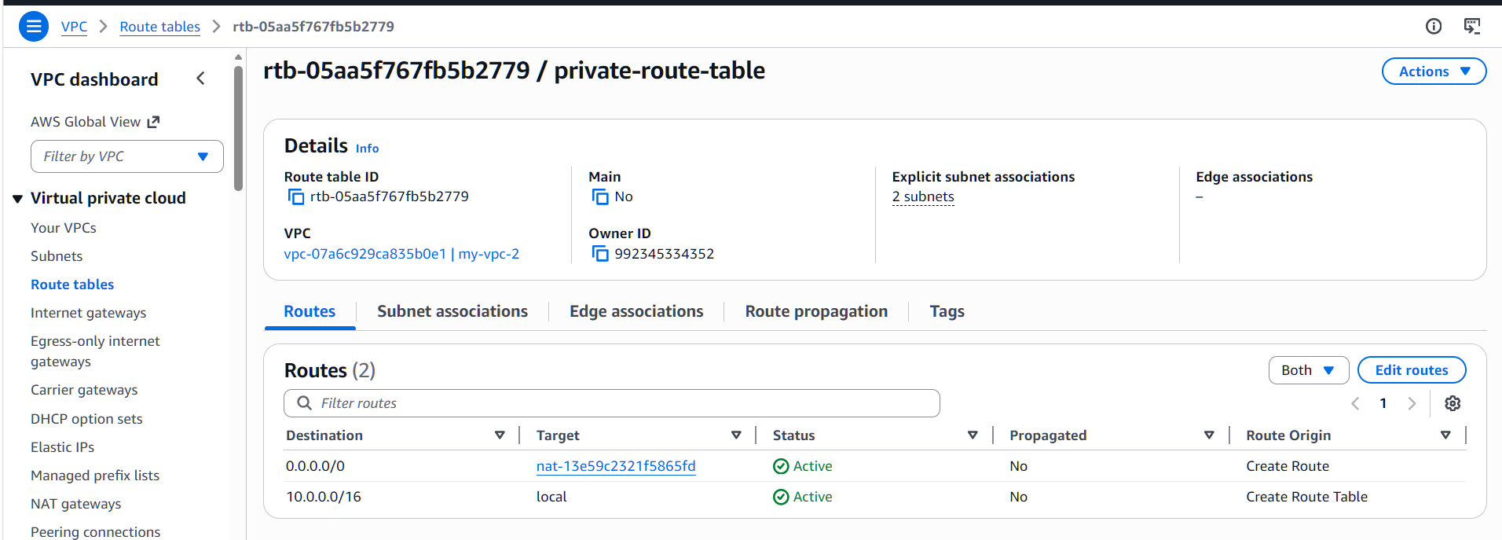
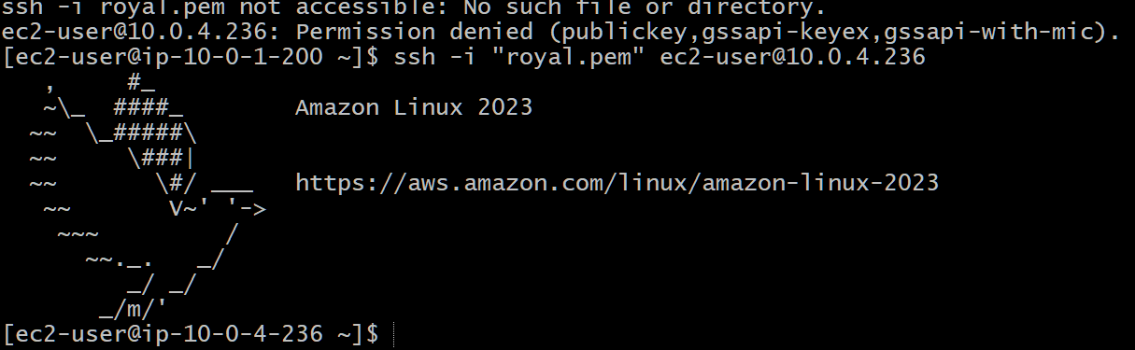
9) Install Apache Tomcat in private EC2 and deploy a sample app.
Login into private instance
install apache Tomcat on the private instance you create
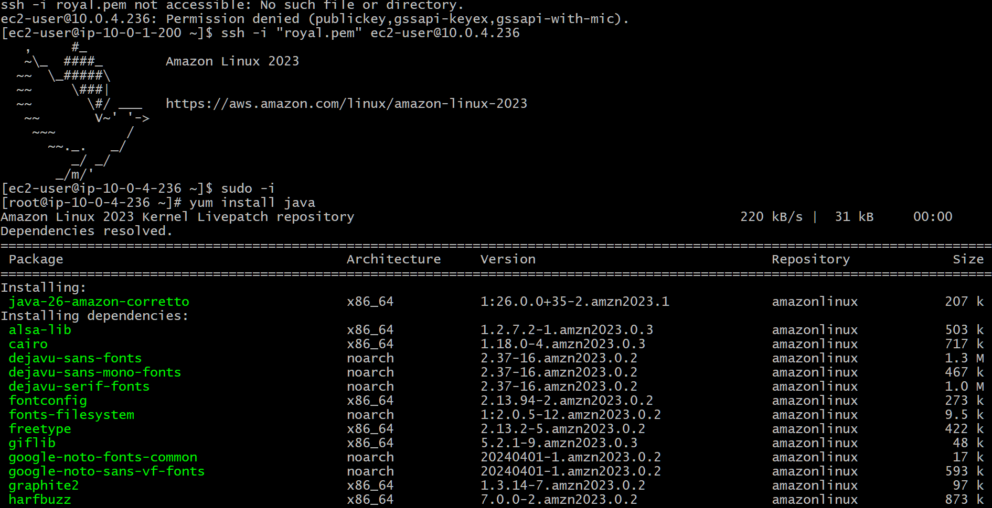
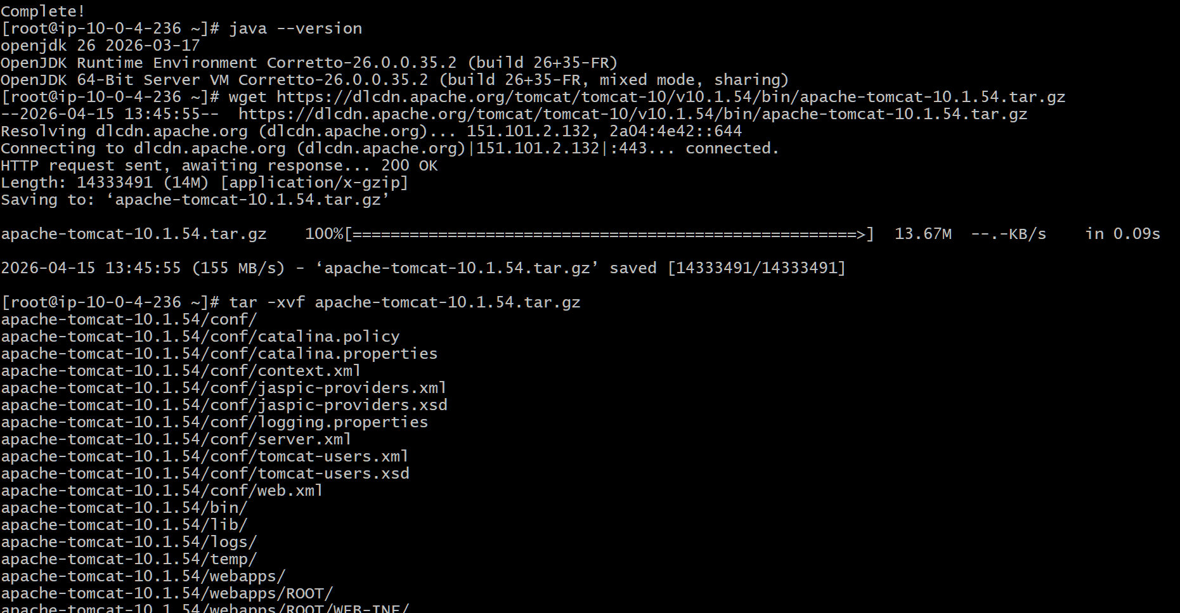
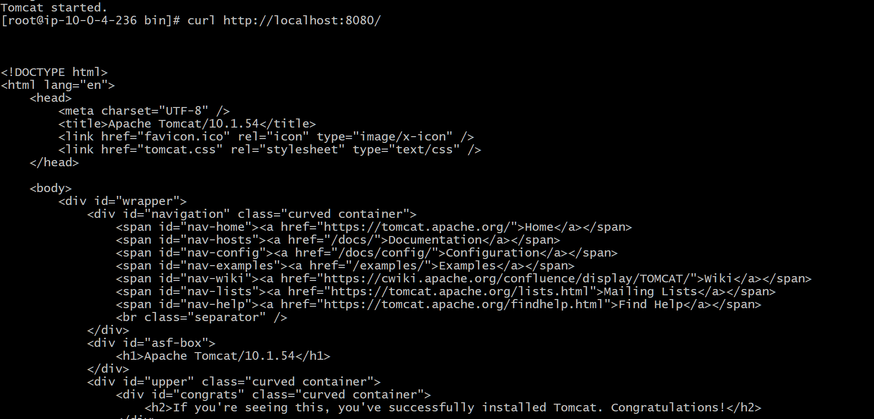
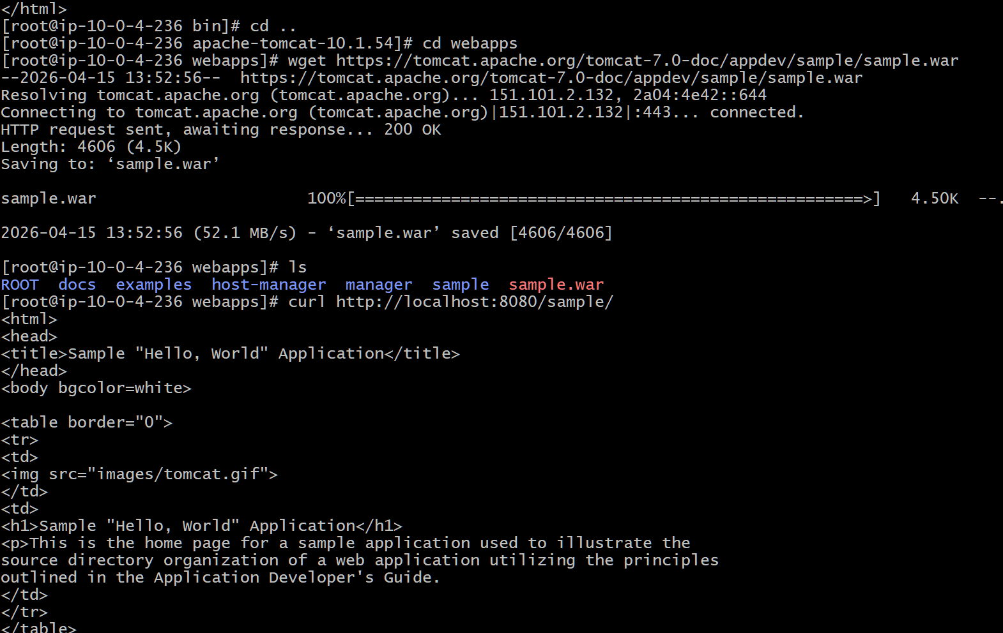
10) Configure VPC flow logs and store the logs in S3 and CloudWatch.
Create S3 Bucket (for logs)
->Create Flow Logs for VPC
->Create Flow Logs for S3
